


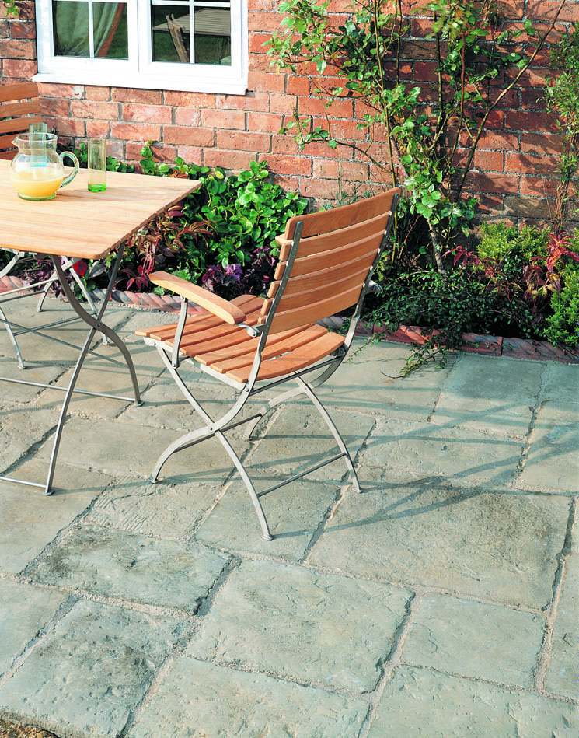
Benefits Of Using Geo-fix®

Known problems using wet sand / cement mix: -

- High incidence of staining
- Frost damage
- High cost in use – time consuming
- Curing times
- High cost in maintenance
- Variable mixes / technical qualities
- Failures due to expansion and contraction of paving elements
- Pigmented products can cause staining to porous paving.

- All the above problems are SOLVED BY USING GEO-FIX®
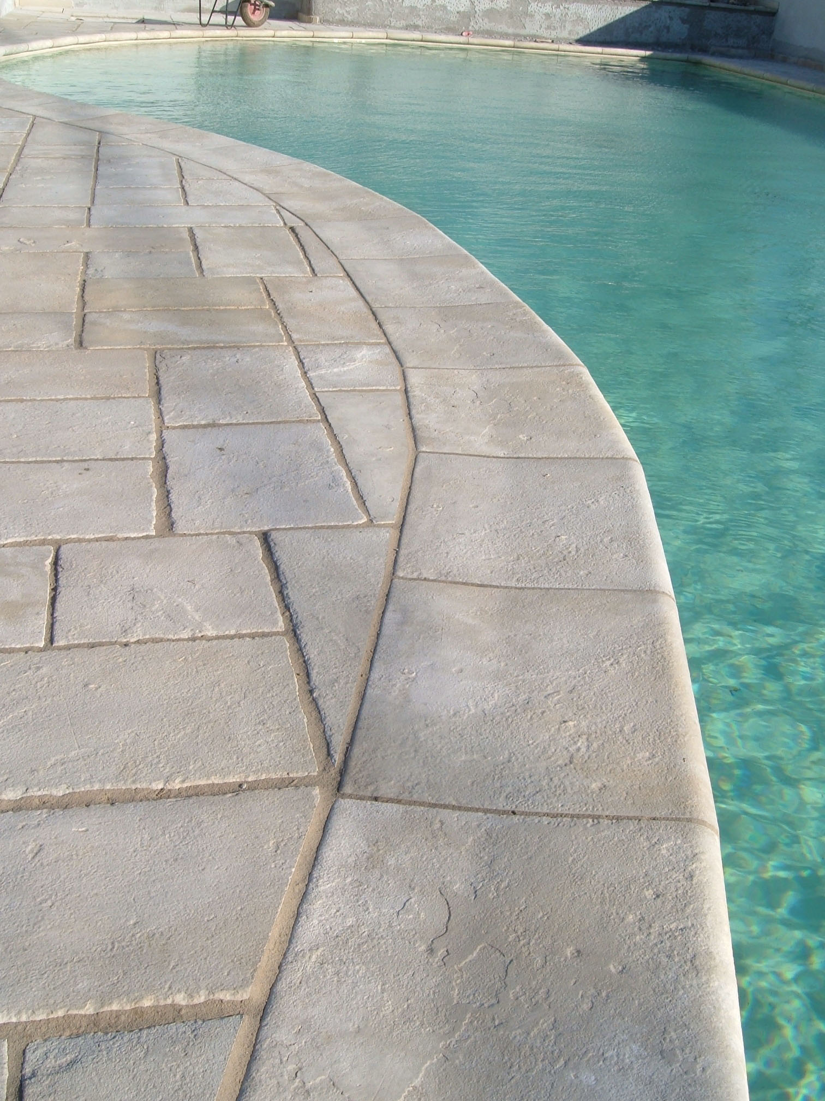
Known problems using dry sand / cement mixes for jointing

- High incidence of staining particularly after rainfall
- Refilling due to settlement
- Ongoing maintenance
- Joint removal by weather
- Joint removal by mechanical cleaners
- Failure due to expansion and contraction of paving elements.
- Pigmented products can cause staining to porous paving.

- All the above problems are SOLVED USING GEO-FIX®

Other Benefits

P Ease of use:
  - simply brushes in
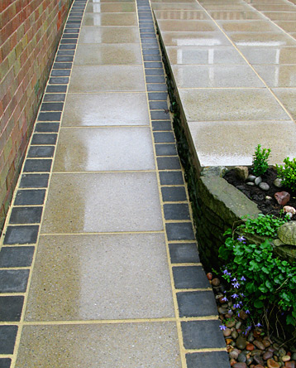
  - no skills required
  - excess brushes away
  - low temperature application – All Weather can be applied at temperatures down to 3ºC and Original at -5ºC.
  - Quick drying (colder temperatures will affect cure rate)

P Value:
  - 20 times faster than pointing
  - saves time and money
  - low maintenance

P Performance:
  - durable and long lasting
  - semi rigid allows for expansion / contraction of paving elements
  - weather resistant joints
  - resistant to cleaning equipment, including power washers
  - high compressive strength
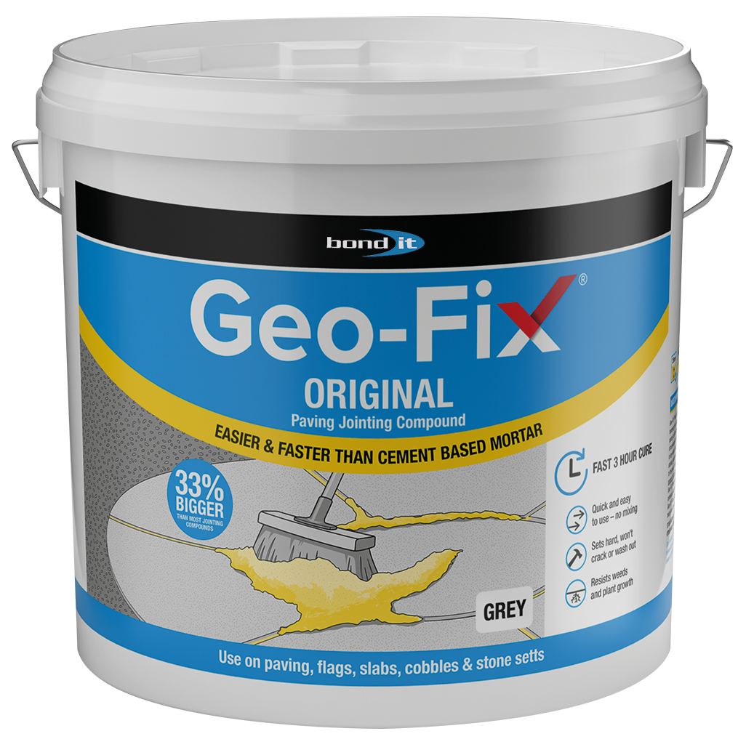
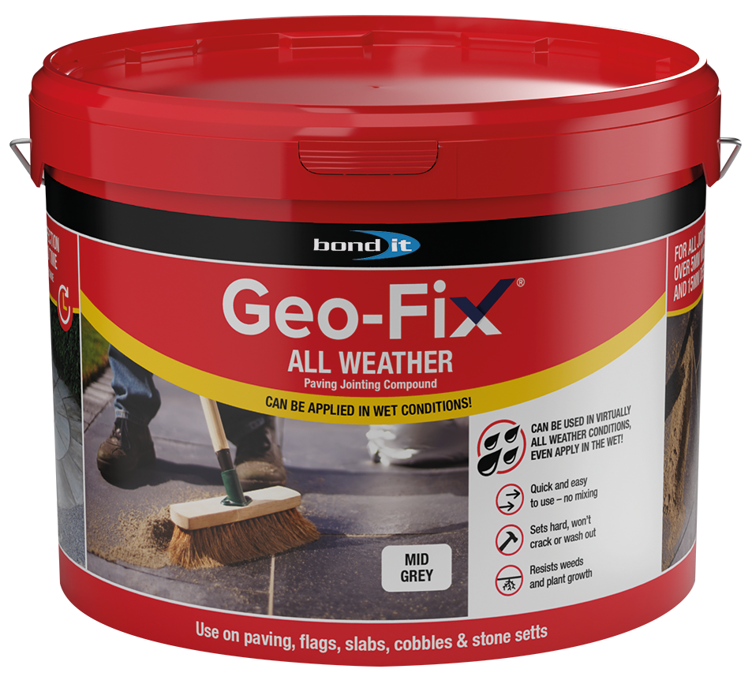
P Looks:
  - superior finish
  - non staining as formulated from colour fast sand rather than coloured pigments
  - neat
  - weed resistant

